

Hi-Desert CSL presents:

“**Enrich your Spirit Retreat” at**

**RW Spiritual Center** 8088 High Rd., Lucerne Valley, CA

May 16 - 18, 2025

**Escape to Tranquility: The Ultimate Retreat Experience**

Imagine stepping away from the hustle and bustle of daily life and immersing yourself in a serene environment where relaxation meets rejuvenation. Enrich Your Spirit Retreat is presented at the majestic 900-acre R.W. Ranch spiritual retreat center in Lucerne Valley, California. Sessions will be conducted in comfortable, air-conditioned meeting rooms.

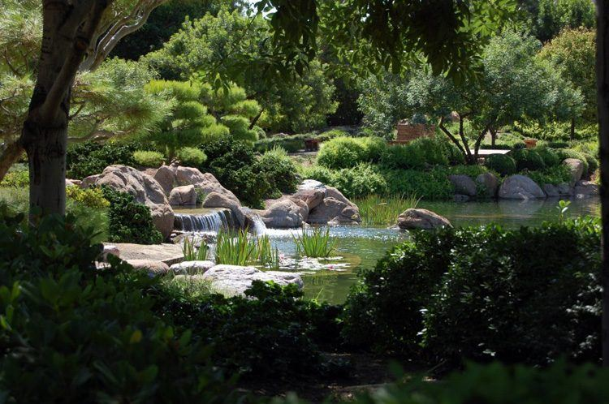**What Awaits You:**

* **Idyllic Setting:** Surround yourself with nature's beauty as you unwind in a picturesque environment, far from the stresses of the modern world.
* **Holistic Wellness:** Indulge in a variety of wellness activities, including yoga sessions with stunning views, guided meditation, swimming pool and sound bath designed to relax your body and calm your mind.
* **Gourmet Dining:** Savor delicious, locally-sourced meals prepared by top chefs, tailored to nourish your body and delight your taste buds.
* **Personal Growth:** Engage in workshops led by expert facilitators that inspire self-discovery, creativity, and personal growth. Whether you're looking to deepen your spiritual practice or simply find inner peace, there's something for everyone.
* **Comfort & Luxury:** Stay in beautifully designed accommodations that offer the perfect blend of comfort and elegance, ensuring you feel at home while being pampered.

**Arrive Friday, May 16th Check in 4pm - Check out Sunday, May 18 at 1pm**

To register please click the link:  <https://hdcsl.breezechms.com/form/c9cf6f>

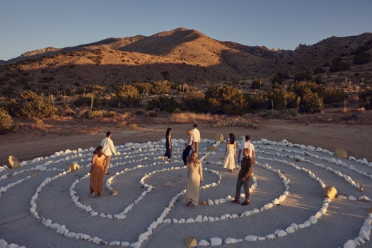 If you have any questions, please call 760-242-2302 or cslapplevalley@gmail.com!

Click the QR code to register!!

**All inclusive:** ALL weekend retreat activities, well-appointed lodging, and six organic, chef-prepared meals. The grounds will be for our exclusive use throughout the weekend.

**Retreat Room Pricing with payment plans are available! Simply click the QR code below!**

**Shared Bedroom with Shared Bathroom (same gender) – $684pp**

Double occupancy bedroom with a bathroom that is shared with two attendees in an adjacent room. The bathroom has private shower and toilet areas, and double sinks. These accommodations are single beds

.

**Triple Occupancy Bedroom – $684 per person**

Triple occupancy bedroom with shared bathroom. These rooms are located closest to the meeting and dining rooms in the main lodge. Access to the main lodge is possible without requiring the use of stairs or steps. These accommodations are single beds.

**Couples Room/Double Room with Private Bathroom – $774 per person**

Couples room with two single beds and a private bathroom.

**Private Bedroom with Shared Bathroom (same gender) – $849**

Private bedroom with a bathroom that is shared with one or two attendee(s) in an adjacent room. The bathroom has private shower and toilet areas, and double sinks. These accommodations are single beds.



To register please click the link:  <https://hdcsl.breezechms.com/form/c9cf6f>

 If you have any questions, please call 760-242-2302 or cslapplevalley@gmail.com! Click the QR code to register!!

For more information about the retreat center visit <https://www.royalway.org>

* **LOCATION:** The R.W. Ranch in Lucerne Valley, California is a ninety-minute drive from Ontario International Airport. Orange County and Los Angeles International Airports are each 2 to 2-1/2 hours away. 20 minutes from Apple Valley - Royal Way Spiritual Center - 8088 High Road, Lucerne Valley, CA 92356

**Retreat FAQs**

**Is everything included?**

Yes! The retreat price includes all retreat activities, comfortable lodging, and six organic meals from dinner on Friday evening through lunch on Sunday.

**What time does the retreat start and finish?**

The retreat will start on Friday, May 16th. Registration will begin at 4:00 pm. Dinner is at 6:00 pm. You may arrive as early as 3:00 pm. The retreat will end after lunch on Sunday, May 18th. Checkout is to be completed no later than 1:00 pm.

**Can I arrive at the Retreat Center prior to May 16, 2025?**

Because of other events at the ranch, the Retreat Center will NOT be open to our group before May 16th at 3:00 pm. To search for hotels in the Apple Valley, California area (near the Retreat Center) or the Ontario Airport area, go to: [www.hotels.com](http://www.hotels.com/). Apple Valley has movie theaters and restaurants, if you find yourself in the area earlier than 3:00 pm.

**Can I extend my stay at Retreat Center following the retreat?**

Because of other events at the ranch, the Retreat Center cannot accommodate retreat participants after the retreat ends.

**What is the nearest airport to the Retreat Center?**

Ontario International Airport is the closest airport. The drive time to the ranch is about 90 minutes in normal traffic. [Rental cars](https://www.enterprise.com/en/car-rental/locations/us/ca/la-ontario-international-airport-320n.html) are available. You may use Lyft and Uber to reach the ranch. as well. Orange County and Los Angeles International Airports are each 2 to 2-1/2 hours away.

**Will internet be available? Can I call family/friends/work?**

There is free wireless internet access in the main building and dining room, but not in the bedrooms. The retreat is an opportunity for great focus. To fully benefit from your time on retreat, we recommend not using internet or phone service once the retreat has started. For emergencies during the retreat, family can contact you if necessary, by calling the retreat center at 760-247-8984.

**What will the weather be like and what should I bring?**

The retreat center lies in the high Mojave Desert. Temperatures in May range from the mid-50s F at night to the mid-90s F during the day. Because the retreat meeting room is air-conditioned, and the nights are cool, layered clothing is recommended for both indoors and outdoors. There is a pool and indoor spa on-site, so you might want to bring a swimsuit. Sunscreen lotion, socks to wear in the meeting room, and a flashlight are highly recommended. Open-toed shoes are not recommended, as the uneven gravel hills require sturdy treaded shoes. Please note the main workshop room requires socks- no shoes for entering. Bedding, towels, and bar soap are provided. Please bring your own toiletries including shampoo and blow dryer, if desired.

**I have mobility concerns. Should I inform you of that?**

The ranch property is rustic with sloped walkways and stairs. If you have mobility issues, we may be able to house you in a Mobility Room closer to our meeting room which will reduce the distance you will need to travel to our group sessions and dining.

**Smoking Policy**

Please note that due to fire danger, the entire Retreat Center property is non-smoking by order of the local fire department.

Please feel free to 760-242-2302 or email [cslapplevalley@gmail.com](mailto:cslapplevalley@gmail.com) for any further questions.